COMPONENTS:
- React Component are reusable building block of code which associated with logic.
- Using this we can build SPA
- Types of Component :
- Class based component
- Function based components
Note :
- Name of the component should start from uppercase and .jsx extension.
Ex : App.jsx
- We can represent component in 2 ways
- < App/>
- <App><App/>

Class based component :
App.jsx
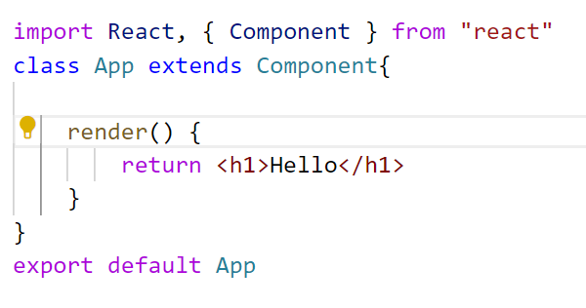
main.jsx
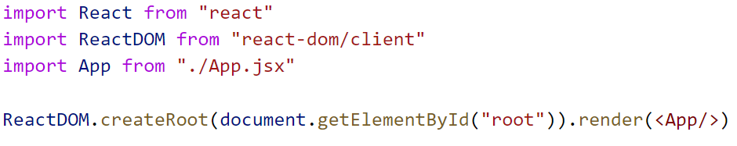
Note : In class based component there is one built in property called as state so class based component called as statefull Component.

Function based component :
App.jsx
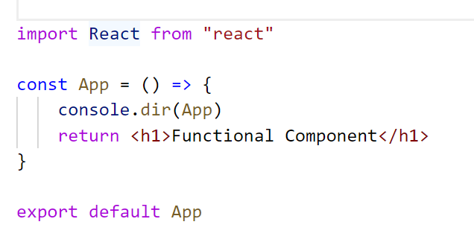
main.jsx
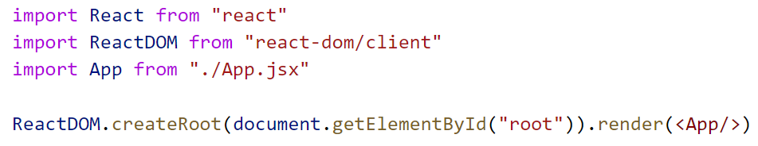
Note : In function based component there is no built in property called as state so function based component called as stateless Component.

Difference between Class based and Function based component
(important interview question)
Class Based | Function Based
It is called statefull | It is called stateless
Hooks are not supported | Hooks are supported
Life Cycle methods are present | Life Cycle methods are not present
Render method is mandatory | Render method is not mandatory
this keyword points to current class based component | no this keyword

JSX: (Javascript XML) :
- It is the combination of JavaScript and XML.
- It is an extension to JS syntax allows you to write HTML-like code when working with React.

App.jsx

In this example code inside return (<h1> Functional Component</h1>) statement looks similar to HTML, but it is actually JSX.

JSX RULES :
- When you want to render more than one element wrap them with one parent and ( )

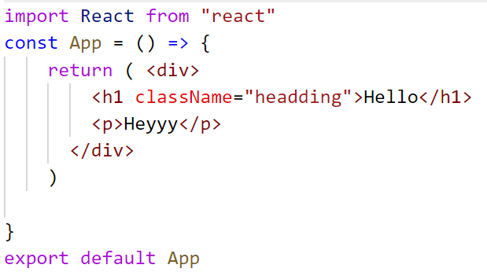

Note : In the above example we have used <div> </div> as a parent .So in this case <div></div> will create one new node. In order to avoid this we have to use fragments as a parent.

Wrapping with fragments

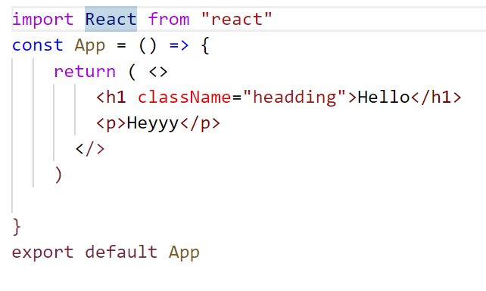

- In JSX every element must be closed
- In JSX all HTML tags must be properly closed.
Example:
In HTML | In JSX
<input type = “text “> | <input type="text" />  Or  <input type="text"></input>
<br> | <br />  Or  <br></br>

App.jsx
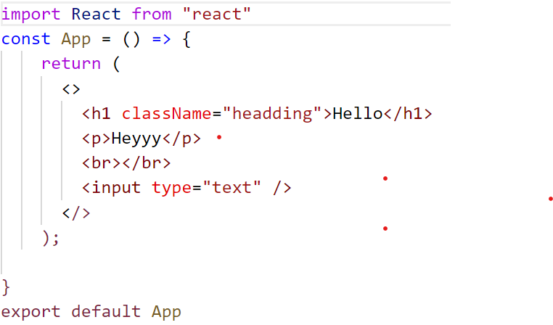

- In JSX in order access the variable we need to wrap them with { }
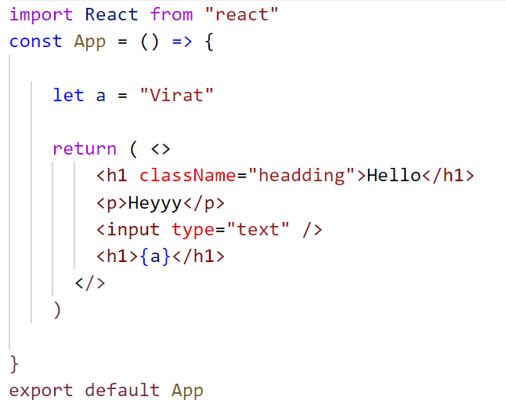
- CamelCase Conventions

HTML | JSX
class | className
for | htmlFor

JS Events that we use here should also be in camelCase
onclick-----------------------onClick

